**Manual for diagram configurator [EN]**

**Tab diagram type**

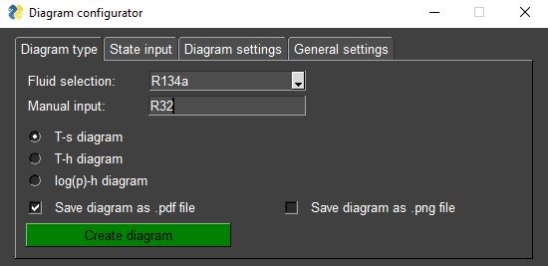

**Fluid selection** select fluid from list with most relevant fluids

**Manual input** manual input of fluid possible; fluid selection is not effective anymore in case manual input is not empty

**Radio buttons** selection between T-s, T-h and log(p)-h diagram

**Save diagram as** diagram will be saved as .pdf file in case check box is active  
**.pdf file**

**Save diagram as** diagram will be saved as .png file in case check box is active  
**.png file**

**Create diagram** shows the diagram with all selected/entered options/settings by the user (pressing ENTER has the same effect)

**Tab state input**

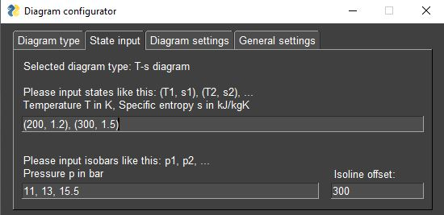

**State input** input states (points in diagram) like this:  
(x1, y1), (x2, y2), …

**Isoline input** input isolines (isobars, isotherms) like this:  
x1, x2, …

**Isoline offset** a factor describing how far the isolines will be drawn in overheated and subcooled region

**Tab diagram settings**

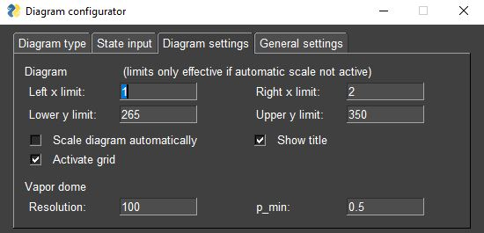

**Left x limit** Left limit of x-axis

**Right x limit** Right limit of x-axis

**Lower y limit** Lower limit of y-axis

**Upper y limit** Upper limit of y-axis

**Scale diagram** diagram will be scaled automatically based on entered states and **automatically** isolines as well as vapor dome in case check box is active; enteredlimits are useless then

**Show title** fluid and diagram type will be shown in title of diagram in case check box is active

**Activate grid** grid will show up in diagram for better orientation in case check box is active

**Resolution** amount of points to approximate saturated liquid line and saturated vapor line (vapor dome)

**p_min** lower vapor dome pressure (in bar); vapor dome will be always drawn right up to critical point

**Tab general settings**

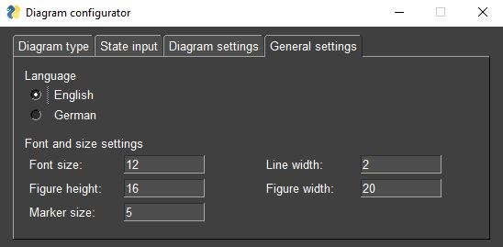

**Language** English and German are selectable; selection has influence on GUI and diagram

**Font size** font size of all labels in diagram

**Line width** line width of state lines, vapor dome and isolines

**Figure height** height of diagram

**Line width** width of diagram

**Marker size** size of markers in diagram